What is Redux and why do we need it?

1. What is Redux?
Redux is a predictable state management library that helps you store, manage, update, and share application data across multiple components.

In React, you normally manage component state using useState and share data using props or Context API. As an application grows, managing shared state across many components can become difficult.

Redux provides a centralized store where you can keep shared application state and update it through a defined process.

Think of Redux as a central place for your application's shared data.

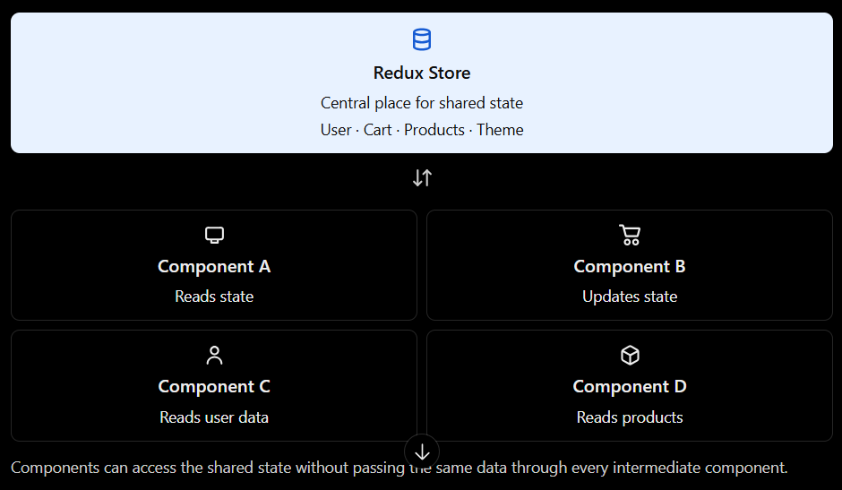

For example, imagine an e-commerce application with:
- A login page that stores user information.
- A navbar that displays the logged-in user's name.
- A product page that adds products to a cart.
- A cart page that displays selected products.
- A checkout page that calculates the total price.
All these components may need access to the same data. Redux can manage that shared state in one central store.

Important: Redux is not a replacement for React. React builds the user interface; Redux helps manage shared application state.

2. Why do we need Redux?
Let's understand the problem Redux solves.

Problem A: Passing props through many components
The Layout component might not need the user information at all. It only passes that information to another component.
This is called prop drilling.

Problem B: Sharing data between unrelated components

Problem C: Managing complex state updates

3. What is the difference between React state and Redux state?

Feature | React useState | Redux
Where state lives | Inside a component | In a central store
Best for | Local UI state | Shared application state
Sharing data | Props or Context, etc. | Components select from the store
Updating data | Call the state setter | Dispatch an action
Example | Is a modal open? | What products are in the cart?
Required setup | Built into React | Redux Toolkit and React-Redux

When should you use Redux?
Redux becomes useful when the same state is needed by multiple components or when its update logic is complex.

Examples include:
- Authenticated user information.
- Shopping cart data.
- Shared application preferences.
- Complex workflows and shared business state.
- Client-side data that many parts of the application need to read or update.
Remember: Don't put every piece of state into Redux. Use local state for local concerns and shared state management when it provides a real benefit.

Redux key concepts

1. Store
The store is the central container that holds Redux state.
In Redux Toolkit, you create a store using configureStore().

2. Action
An action describes what happened or what change is requested.
Examples:
{ type: "cart/addToCart" }
{ type: "cart/removeFromCart", payload: 1 }
The payload contains additional information, such as the product ID.

4. How does Redux work internally?
Redux follows a predictable data flow. Understand these five terms:

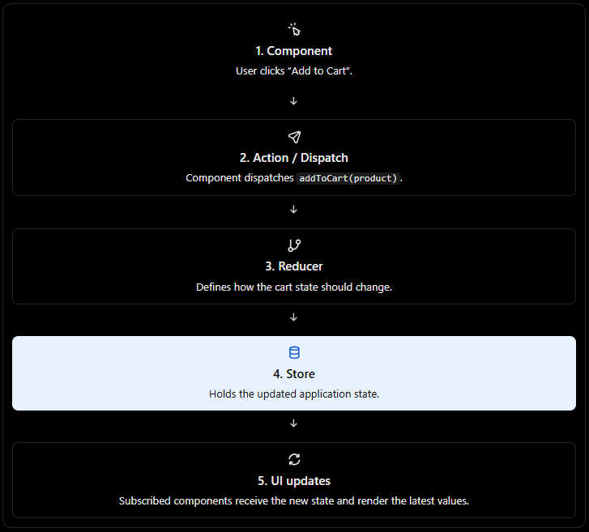

3. Dispatch
dispatch() sends an action to Redux.
const dispatch = useDispatch();

dispatch(addToCart(product));

Here:
- useDispatch() gives your component access to the store's dispatch function.
- addToCart(product) creates an action containing the product.
- dispatch() sends that action through Redux's update process.

4. Reducer
- A reducer determines how the state should change in response to an action.
For example, when an addToCart action is dispatched, the reducer adds the product to the cart or updates its quantity.
- With Redux Toolkit, you commonly define reducers inside createSlice().

5. Selector
A selector allows a component to read a particular part of the Redux state.

const cartItems = useSelector((state) => state.cart.items);

Here, useSelector() reads items from the cart section of the store.

When the selected state changes, React-Redux can trigger a re-render of the component if the selected result is different according to its equality check.

Let's build a complete Redux example

Step 1: Install the packages
npm install @reduxjs/toolkit react-redux
- @reduxjs/toolkit provides the recommended tools for creating Redux state and reducers.
- react-redux connects your React components to the Redux store.

Step 2: Create a slice
Create src/features/counter/counterSlice.js.

import { createSlice } from "@reduxjs/toolkit";

const counterSlice = createSlice({
name: "counter",

initialState: {
value: 0,
},

reducers: {
increment: (state) => {
state.value += 1;
},
decrement: (state) => {
state.value -= 1;
},
incrementByAmount: (state, action) => {
state.value += action.payload;
},
},
});

export const {
increment,
decrement,
incrementByAmount,
} = counterSlice.actions;

export default counterSlice.reducer;
Let's break this down.
- createSlice() creates a slice of your Redux state, along with its reducer and action creators.
- name: "counter" identifies this slice and helps form action type names.
- initialState defines the initial counter value.
- reducers contains the logic for each action.
- state.value += 1 looks like a direct mutation, but Redux Toolkit uses Immer to produce an immutable state update safely.
- action.payload contains the value passed when the action creator is called.
- counterSlice.actions provides action creators such as increment() and incrementByAmount(5).
- counterSlice.reducer is the reducer that the store will use.

Step 3: Configure the Redux store
Create src/app/store.js.

import { configureStore } from "@reduxjs/toolkit";
import counterReducer from "../features/counter/counterSlice";

export const store = configureStore({
reducer: {
counter: counterReducer,
},
});

The counter key determines where the slice's state appears in the overall store.
So, the state is accessible as:
state.counter.value

This is why the selector below uses state.counter.value, rather than state.value.

Step 4: Connect Redux to React
Update src/main.jsx.

import React from "react";
import ReactDOM from "react-dom/client";
import { Provider } from "react-redux";
import { store } from "./app/store";
import App from "./App";

ReactDOM.createRoot(
document.getElementById("root")
).render(
<Provider store={store}>
<App />
</Provider>
);
The Provider makes the Redux store available to React components underneath it.
Without the appropriate provider, useSelector() and useDispatch() cannot access that store through the React-Redux context.
Step 5: Use Redux inside a component
Update src/App.jsx.

import { useSelector, useDispatch } from "react-redux";

import {
increment,
decrement,
incrementByAmount,
} from "./features/counter/counterSlice";

export default function App() {
const count = useSelector(
(state) => state.counter.value
);

const dispatch = useDispatch();

return (
<div>
<h1>Counter: {count}</h1>

<button onClick={() => dispatch(increment())}>
Increment
</button>

<button onClick={() => dispatch(decrement())}>
Decrement
</button>

<button
onClick={() => dispatch(incrementByAmount(5))}
>
Add 5
</button>
</div>
);
}

When you click Increment in the actual Redux example, this sequence occurs:
- The button calls dispatch(increment()).
- Redux receives the counter/increment action.
- The counter reducer runs state.value += 1.
- Redux updates the store with the new state.
- useSelector() detects the changed counter value.
- React renders the component with the updated count.
- The important point is that the component does not directly update the Redux store. It dispatches an action, and the reducer defines the update.

6. Why do we use Redux Toolkit instead of traditional Redux?
You will often hear two terms: Redux and Redux Toolkit (RTK).
Redux is the state management library. Redux Toolkit is the officially recommended way to write Redux logic.
Traditional Redux approach | Redux Toolkit approach
More manual setup | Less boilerplate
Often requires manually defined action types | createSlice() generates action creators
Reducers must return immutable updates manually | Immer enables safe mutation-style reducer code
Store configuration is more manual | configureStore() provides sensible defaults
Async workflows require additional setup | createAsyncThunk() helps handle common async workflows

7. How Redux handles API calls
Suppose your application needs to fetch products from an API.
The store may need to track three things:
- loading: Is the request in progress?
- items: What products were returned?
- error: Did the request fail?
Redux Toolkit provides createAsyncThunk() for common asynchronous operations.

import {
createSlice,
createAsyncThunk,
} from "@reduxjs/toolkit";

export const fetchProducts = createAsyncThunk(
"products/fetchProducts",
async () => {
const response = await fetch(
"https://fakestoreapi.com/products"
);

if (!response.ok) {
throw new Error("Failed to fetch products");
}

return response.json();
}
);

const productsSlice = createSlice({
name: "products",

initialState: {
items: [],
loading: false,
error: null,
},

reducers: {},

extraReducers: (builder) => {
builder
.addCase(fetchProducts.pending, (state) => {
state.loading = true;
state.error = null;
})

.addCase(fetchProducts.fulfilled, (state, action) => {
state.loading = false;
state.items = action.payload;
})

.addCase(fetchProducts.rejected, (state, action) => {
state.loading = false;
state.error =
action.error.message || "Something went wrong";
});
},
});

export default productsSlice.reducer;

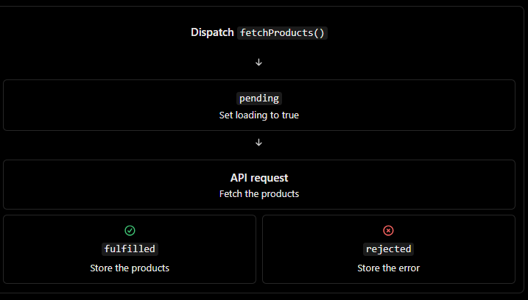

Notice that extraReducers handles the lifecycle actions generated by createAsyncThunk().

A component can trigger the request like this:

const dispatch = useDispatch();

useEffect(() => {
dispatch(fetchProducts());
}, [dispatch]);
It can read the result like this:
const { items, loading, error } = useSelector(
(state) => state.products
);

- This pattern helps you manage API request state consistently across components.
- One important distinction: Redux is not itself an API-fetching library. createAsyncThunk is one way to handle async work with Redux Toolkit. For applications that primarily need API caching, request deduplication and cache invalidation, RTK Query or TanStack Query (React Query) may be a better fit.

8. When should you avoid Redux?
Redux is useful, but it is not necessary for every React application.

You probably don't need Redux when:
- Your application has only a few components and little shared state.
- Most state belongs to individual forms or components.
- Props and Context API already solve your sharing needs cleanly.
- You only need to fetch and cache server data, for which a query library may be sufficient.

You might benefit from Redux when:
- Many unrelated components need to read and update the same data.
- Your application has complex shared business logic.
- You want consistent state transitions and strong debugging tools.
- Multiple features depend on the same client-side state, such as authentication and a shopping cart.
Also, Redux state is not automatically saved after a browser refresh. By default, the store is recreated when the application starts. If you need persistence, you must implement it separately, for example with carefully chosen local storage persistence. Authentication credentials and sensitive tokens require additional security considerations.

- Redux is a predictable state management library used to manage shared application state in React applications. It provides a centralized store that multiple components can access without passing data through every level of the component tree.
- Redux follows a unidirectional data flow. A component dispatches an action, the reducer processes that action and produces the next state, and the store makes the updated state available to subscribed components. React-Redux provides hooks such as useSelector and useDispatch to connect React components to the store.
- In modern applications, Redux Toolkit is the recommended approach because it reduces boilerplate through utilities such as configureStore, createSlice and createAsyncThunk.
- Redux is particularly useful for shared state such as authentication, shopping carts and complex application workflows. For local UI state, React's useState is usually sufficient.

Concept | What you must understand
configureStore() | Create the Redux store and configure reducers and middleware
createSlice() | Define initial state, reducers, and generated actions
action.payload | Pass data to a reducer
extraReducers | Respond to actions defined outside the slice, including async thunk lifecycle actions
createAsyncThunk() | Handle asynchronous work such as API requests
combineReducers | Combine multiple reducers into a root reducer when needed
Immer | Why RTK lets you write mutation-like reducer code safely
Redux DevTools | Inspect actions, state changes, and debugging history
Multiple slices | Organize auth, cart, users, products, and other state domains

Important interview question: Why can we write state.count += 1 inside a Redux Toolkit reducer?
Because RTK uses Immer to produce an immutable next state from mutation-like code. This does not mean you should directly mutate Redux state in a component.

Asynchronous Redux and API handling

- createAsyncThunk — make API calls and dispatch lifecycle actions.
- pending, fulfilled, and rejected — handle loading, success, and failure.
- extraReducers — update state based on those lifecycle actions.
- rejectWithValue — return a custom error payload.
- .unwrap() — handle fulfilled results or rejected errors in the calling component.
- API loading, error, empty, and success states.
- condition and request cancellation — avoid unnecessary or obsolete requests.
- RTK Query — API fetching, caching, invalidation, and automatic refetching.

Some Redux concepts
- reducers vs extraReducers: reducers defines a slice's own actions; extraReducers responds to actions defined elsewhere.
- createAsyncThunk vs RTK Query: the former is useful for custom async workflows; the latter is usually preferable for standard server-data fetching and caching.
- Redux vs Context API: Redux is useful for complex shared state, debugging, and structured updates; Context is often enough for simpler shared values.
- Redux state vs local state: keep shared application state in Redux when justified, but keep temporary form input, modal visibility, and similar UI state local when appropriate.

Important API errors to handle in real projects
Error | Example handling
Network error | Show “Check your internet connection”
400 Bad Request | Display validation or request error
401 Unauthorized | Redirect to login or refresh authentication
403 Forbidden | Show an access-denied message
404 Not Found | Show a resource-not-found message
500 server error | Show a server error and allow retry
Empty response | Show “No products found” when the returned array is empty

In Redux Toolkit, extraReducers is used to handle actions that are created outside the slice, especially API request actions created by createAsyncThunk.

Why do we need extraReducers?
Suppose you want to fetch products from an API.
When you call an API, three things can happen:
- Pending — the API request is in progress.
- Fulfilled — the API request succeeds.
- Rejected — the API request fails.
Redux Toolkit's createAsyncThunk() automatically creates these three action types for you.

Without extraReducers, you would not have these handlers in your slice to update loading, data, and error state when the thunk completes

What happens
- createAsyncThunk creates a function called fetchProducts.
- fetchProducts.pending is dispatched when the request starts.
- fetchProducts.fulfilled is dispatched when the request succeeds.
- fetchProducts.rejected is dispatched when the request fails.

The returned JSON data is available in action.payload when fulfilled.

reducers | extraReducers
Handles actions defined inside the slice. | Handles existing actions defined elsewhere.
Commonly used for synchronous state changes. | Commonly used for async thunk lifecycle actions.
Automatically generates action creators. | Does not generate action creators for the cases you handle.
Example: addToCart, logout. | Example: fetchProducts.pending.

combineReducers
- combineReducers: a Redux function that combines multiple reducers.
- auth, products, cart: keys that define where each reducer's state lives in the store.
- authReducer, productsReducer, cartReducer: functions responsible for updating their respective state sections.
- rootReducer: the single reducer that coordinates these individual reducers.

Concept | Purpose
createSlice() | Creates a feature reducer and its action creators.
combineReducers() | Combines multiple reducers into a root reducer.
extraReducers | Lets a slice respond to actions defined elsewhere, such as createAsyncThunk lifecycle actions.
configureStore() | Creates the Redux store and automatically combines reducer objects.

Example

import { configureStore } from "@reduxjs/toolkit";
import { combineReducers } from "redux";

const rootReducer = combineReducers({
auth: authReducer,
products: productsReducer,
cart: cartReducer,
});

export const store = configureStore({
reducer: rootReducer,
});

We can use multiple rootReducer or combine reducer but finally should map to one final root reducer.

Multiple Slices in Redux Toolkit
In Redux Toolkit, multiple slices mean dividing your application's Redux state into separate, manageable pieces, where each slice handles a particular feature or responsibility.
For example, in a React e-commerce application, you might have:
- authSlice — login, logout, and authentication state.
- productsSlice — fetching and managing products.
- cartSlice — adding, removing, and updating cart items.
- usersSlice — managing user information.

You can create two createSlice() instances in a single file and use both slices in the same React form. Here is a complete example using Redux Toolkit.

1. Create two slices in one file

File: formSlices.jsimport { createSlice } from "@reduxjs/toolkit";

// Slice 1: User details
const userSlice = createSlice({
name: "user",
initialState: {
name: "",
email: "",
},
reducers: {
setName: (state, action) => {
state.name = action.payload;
},
setEmail: (state, action) => {
state.email = action.payload;
},
},
});

// Slice 2: Address details
const addressSlice = createSlice({
name: "address",
initialState: {
city: "",
pincode: "",
},
reducers: {
setCity: (state, action) => {
state.city = action.payload;
},
setPincode: (state, action) => {
state.pincode = action.payload;
},
},
});

// Export actions
export const { setName, setEmail } = userSlice.actions;
export const { setCity, setPincode } = addressSlice.actions;

// Export reducers
export const userReducer = userSlice.reducer;
export const addressReducer = addressSlice.reducer;

Notice that both slices are defined in the same file, but each has its own name, initial state, and reducers.

2. Register both reducers in the store
File: store.js

import { configureStore } from "@reduxjs/toolkit";

import {
userReducer,
addressReducer,
} from "./formSlices";

export const store = configureStore({
reducer: {
user: userReducer,
address: addressReducer,
},
});

3. Use both slices in one React form
File: RegistrationForm.jsx

import { useDispatch, useSelector } from "react-redux";

import {
setName,
setEmail,
setCity,
setPincode,
} from "./formSlices";

export default function RegistrationForm() {
const dispatch = useDispatch();

const user = useSelector((state) => state.user);
const address = useSelector((state) => state.address);

return (
<div>
<h2>Registration Form</h2>

<input
placeholder="Name"
value={user.name}
onChange={(e) => dispatch(setName(e.target.value))}
/>

<input
placeholder="Email"
value={user.email}
onChange={(e) => dispatch(setEmail(e.target.value))}
/>

<input
placeholder="City"
value={address.city}
onChange={(e) => dispatch(setCity(e.target.value))}
/>

<input
placeholder="Pincode"
value={address.pincode}
onChange={(e) => dispatch(setPincode(e.target.value))}
/>

<h3>Form Data</h3>
<pre>{JSON.stringify({ user, address }, null, 2)}</pre>
</div>
);
}

Redux DevTools in React Redux

What is Redux DevTools?
Redux DevTools is a debugging tool that lets you inspect your Redux application's state, actions, and state changes over time.
Suppose your application has three slices:
- authSlice — manages login and logout.
- productsSlice — manages products fetched from an API.
- cartSlice — manages shopping cart items and quantities.
Without DevTools, you might need to add console.log() statements throughout your code to understand what is happening.

With Redux DevTools, you can inspect which action was dispatched, what the state looked like before and after the action, and whether an action caused an unexpected state change.
1. Action history
See actions such as cart/addToCart, cart/increaseQuantity, and products/fetchProducts/pending.
2. State inspection
Inspect values such as state.cart.items, state.auth.user, and state.products.loading.
3. State change tracking
Compare the state before and after an action to find unexpected changes.
4. Time-travel debugging
Replay or jump between recorded actions to understand how the application reached its current state.

How to install and enable Redux DevTools

Step 1: Install the browser extension
If you use Chrome, open the official extension information here:
Chrome Web Store — search for Redux DevTools and install the Redux DevTools Extension.
Official setup documentation: Redux installation guide.

Step 2: Configure your Redux store
If you are using Redux Toolkit's configureStore, you usually do not need to install another npm package or manually configure DevTools. It is enabled by default.
Redux Toolkit rejectWithValue()

In React + Redux Toolkit, rejectWithValue() is an important concept when handling API errors, especially when using createAsyncThunk().

What is rejectWithValue()?
rejectWithValue() is a function provided by Redux Toolkit inside a createAsyncThunk callback. It lets you return a custom error payload when an asynchronous operation fails.

Example, imagine your React application calls a login API.
The server returns:
{
"message": "Invalid email or password"
}
You want to display that exact message in your React component.
That's where rejectWithValue() helps.

Example
import { createAsyncThunk } from "@reduxjs/toolkit";

export const loginUser = createAsyncThunk(
"auth/loginUser",
async (credentials, { rejectWithValue }) => {
const response = await fetch("/api/login", {
method: "POST",
headers: {
"Content-Type": "application/json",
},
body: JSON.stringify(credentials),
});

const data = await response.json();

if (!response.ok) {
return rejectWithValue(data);
}

return data;
}
);

Here is the important line:
return rejectWithValue(data);

It tells Redux Toolkit:
- The asynchronous operation has failed.
- Treat this thunk as rejected.
- Put data into the rejected action's payload.
- Let your extraReducers handle that payload.
Important: rejectWithValue() does not automatically display an error message or update your UI. You must handle the rejected action in your slice and display the error in your component.

Why do we need rejectWithValue()?
Consider these two approaches.

Approach A: Throw an error
if (!response.ok) {
throw new Error("Invalid email or password");
}

Redux Toolkit catches the error and creates a rejected action. The error information is normally available in action.error.message.

Approach B: Use rejectWithValue()

if (!response.ok) {
return rejectWithValue({
message: "Invalid email or password",
status: 401,
});
}

The custom object is available in action.payload, while action.error.message is typically "Rejected".

Main difference is where the error information is stored.
Feature | throw new Error() | rejectWithValue()
Rejects the thunk | Yes | Yes
Custom message | action.error.message | action.payload.message
Custom error object | Usually reduced to a serialized error | Can carry a custom serializable payload
HTTP status and validation details | Need extra handling to preserve them | Can return them together in the payload
Best use | Unexpected exceptions | Expected API and business errors

Your rejected action contains data conceptually like this

{
type: "auth/loginUser/rejected",
payload: {
message: "Invalid email or password",
status: 401
},
error: {
message: "Rejected"
},
meta: {
requestStatus: "rejected"
}
}

The important point is that rejectWithValue() lets your Redux state preserve both the message and status code. Your component can then decide whether to show a general error, a retry option, or a status-specific message.

Note that HTTP status codes should come from the actual response; a network failure has no HTTP response status.

Important points

- rejectWithValue(data) — rejects an async thunk with your custom error payload.
- action.payload — reads that custom payload inside extraReducers.
- .unwrap() — lets a component catch the rejected payload in a try/catch block.

Redux Toolkit unwrap()
In Redux Toolkit, unwrap() is mainly used with createAsyncThunk() to get the actual successful API result or catch the API failure directly inside your React component.

1. Why do we need unwrap()?
- Suppose you have a login API.
- If login succeeds, you want to navigate the user to the dashboard.
- If login fails, you want to show an error message.
- You want to perform these actions in the component that triggered the API call.
Redux Toolkit's dispatch() behaves differently from a normal JavaScript promise when used with a createAsyncThunk action.

Consider this thunk:
import { createAsyncThunk } from "@reduxjs/toolkit";

export const loginUser = createAsyncThunk(
"auth/loginUser",
async (credentials) => {
const response = await fetch("/api/login", {
method: "POST",
headers: {
"Content-Type": "application/json",
},
body: JSON.stringify(credentials),
});

if (!response.ok) {
throw new Error("Invalid email or password");
}

return response.json();
}
);
Now dispatch it from a React component:
const result = await dispatch(
loginUser({
email: "user@example.com",
password: "wrong-password",
})
);

- You might expect the await to throw an error because the login failed.
- But it doesn't throw by default.
- Instead, the dispatch promise resolves with a Redux action describing the failure. That action has a type similar to:

{
type: "auth/loginUser/rejected",
payload: undefined,
error: {
message: "Invalid email or password"
}
}

This behavior is intentional: Redux Toolkit returns the fulfilled or rejected action so that the component can inspect it.

You need to call unwrap() with parentheses.

Behavior | Without unwrap() | With unwrap()
API succeeds | Resolves with fulfilled action | Resolves with payload
API fails | Resolves with rejected action | Rejects the promise
catch handles thunk rejection automatically | No | Yes
Useful for | Inspecting action metadata | Component-level success/error flows

The main difference between rejectWithValue and unwrap
- rejectWithValue() is used inside createAsyncThunk() to return a custom error payload when an API request fails.
- unwrap() is used outside the thunk, when dispatching it, to get the successful result or catch the failure using try...catch.

What does rejectWithValue() do?
If login fails, it creates a rejected Redux action with the custom data in action.payload.

What does unwrap() do?
On success, it returns the actual API response payload.
On rejection through rejectWithValue(), it throws the custom rejection payload into catch.

In this Redux Toolkit code
async (_, { rejectWithValue })

The _ represents the first parameter that we are intentionally not using.

Why do we use _?
In Redux Toolkit, createAsyncThunk passes two main arguments to your async function:
- arg — the argument passed when dispatching the thunk.
- thunkAPI — an object containing utilities such as rejectWithValue, dispatch, and getState

Here, _ means we don't need the first argument because we aren't passing any data to the API request.

Redux Persist in React

Redux persistence means saving selected Redux store data so that it remains available even after the user refreshes the browser or closes and reopens the application.

Normally, Redux stores data in memory. When you refresh the page, the Redux store is recreated, and its state returns to its initial values. Persistence helps you restore saved state.

Why do we need Redux persistence?
Suppose you have a React shopping application.

Without persistence, this can happen:

Before refreshing
The user is logged in, and the cart contains a laptop.

User refreshes the browser
React reloads, and the Redux store is initialized again.

After refreshing
The cart may be empty, and the Redux login state may be reset.
With Redux persistence, selected state is saved in browser storage and restored when the application starts.

What is Redux Persist?
redux-persist is a library that helps automatically save and rehydrate Redux state.

Rehydration means loading previously persisted data back into the Redux store.

It generally works like this:
- The user changes application state.
- Redux updates its store.
- Redux Persist saves the configured state to storage.
- The user refreshes the browser.
- Redux Persist reads the saved state.
- The application restores that state into Redux.
You do not need to manually write localStorage.setItem() and localStorage.getItem() for every persisted Redux field.

Redux Persist vs localStorage vs Redux Toolkit
These concepts are related, but they are not the same.

Feature | Redux Toolkit | localStorage | Redux Persist
Main purpose | Manage application state | Store data in browser | Persist Redux state
Survives refresh | No, by itself | Yes | Yes, when configured
Automatically saves Redux state | No | No | Yes
Restores Redux state | No, by itself | You must implement it | Yes
Expiration | Not applicable by default | No automatic expiration | Can be configured with additional logic

Redux Persist commonly uses localStorage in web applications, but it also supports other storage engines.

How to implement Redux Persist with Redux Toolkit
Let's implement a simple example with a counter.

Step 1: Install the packages
Run this command in your React project:

npm install @reduxjs/toolkit react-redux redux-persist

Step 2: Create a Redux slice
Create counterSlice.js.

import { createSlice } from "@reduxjs/toolkit";

const counterSlice = createSlice({
name: "counter",

initialState: {
value: 0,
},

reducers: {
increment: (state) => {
state.value += 1;
},

decrement: (state) => {
state.value -= 1;
},
},
});

export const { increment, decrement } =
counterSlice.actions;

export default counterSlice.reducer;

This is a normal Redux Toolkit slice. It does not contain any persistence logic.

Step 3: Configure Redux Persist in the store
Create store.js.

import { configureStore } from "@reduxjs/toolkit";
import {
persistStore,
persistReducer,
} from "redux-persist";

import storage from "redux-persist/lib/storage";
import counterReducer from "./counterSlice";

// 1. Configure persistence
const persistConfig = {
key: "root",
storage,
};

// 2. Wrap the reducer with persistence
const persistedReducer = persistReducer(
persistConfig,
counterReducer
);

// 3. Create the Redux store
export const store = configureStore({
reducer: {
counter: persistedReducer,
},

// 4. Handle Redux Persist's internal actions
middleware: (getDefaultMiddleware) =>
getDefaultMiddleware({
serializableCheck: {
ignoredActions: [
"persist/PERSIST",
"persist/REHYDRATE",
"persist/REGISTER",
"persist/PAUSE",
"persist/FLUSH",
"persist/PURGE",
"persist/REHYDRATE",
],
},
}),
});

// 5. Create the persistence controller
export const persistor = persistStore(store);

Here is what each important part does:
- persistConfig: Defines how persistence works.
- key: "root": Defines the key prefix used for persisted state.
- storage: Uses browser localStorage through Redux Persist's storage adapter.
- persistReducer(): Wraps your reducer so changes can be persisted and saved state can be restored.
- persistStore(): Creates the persistence controller used to manage rehydration, flushing and purging.
A small improvement: The ignoredActions list above includes persist/REHYDRATE twice. You can remove the duplicate; it has no functional benefit. A clean version of that list is:

Step 4: Add PersistGate to React
In your main.jsx or index.js:

import React from "react";
import ReactDOM from "react-dom/client";
import { Provider } from "react-redux";
import { PersistGate } from "redux-persist/integration/react";

import App from "./App";
import { store, persistor } from "./store";

ReactDOM.createRoot(
document.getElementById("root")
).render(
<Provider store={store}>
<PersistGate loading={<p>Loading saved state...</p>} persistor={persistor}>
<App />
</PersistGate>
</Provider>
);

Why do we need PersistGate?
When the application starts, Redux Persist might need time to read the saved state. PersistGate prevents the wrapped application from rendering until rehydration has completed.

Without it, components may initially see the default state and briefly display the wrong data.

Step 5: Use the persisted state in a component
Create App.jsx:

import { useSelector, useDispatch } from "react-redux";
import { increment, decrement } from "./counterSlice";

export default function App() {
const count = useSelector(
(state) => state.counter.value
);

const dispatch = useDispatch();

return (
<div>
<h2>Counter: {count}</h2>

<button onClick={() => dispatch(increment())}>
Increment
</button>

<button onClick={() => dispatch(decrement())}>
Decrement
</button>
</div>
);
}

Can we persist multiple Redux slices?
Yes. In real-world React applications, you often have multiple slices, such as auth, cart, products, and userPreferences.
You can persist the entire Redux store or only selected slices.

Here is how you can configure persistence for multiple slices.

import { configureStore, combineReducers } from "@reduxjs/toolkit";
import {
persistReducer,
persistStore,
} from "redux-persist";
import storage from "redux-persist/lib/storage";

import authReducer from "../features/auth/authSlice";
import cartReducer from "../features/cart/cartSlice";
import productsReducer from "../features/products/productsSlice";

const rootReducer = combineReducers({
auth: authReducer,
cart: cartReducer,
products: productsReducer,
});

const persistConfig = {
key: "root",
storage,
whitelist: ["cart", "auth"],
};

const persistedReducer = persistReducer(
persistConfig,
rootReducer
);

export const store = configureStore({
reducer: persistedReducer,
middleware: (getDefaultMiddleware) =>
getDefaultMiddleware({
serializableCheck: {
ignoredActions: [
"persist/PERSIST",
"persist/REHYDRATE",
"persist/REGISTER",
"persist/PAUSE",
"persist/FLUSH",
"persist/PURGE",
],
},
}),
});

export const persistor = persistStore(store);

Notice this configuration:
whitelist: ["cart", "auth"]

Only the cart and auth slices are persisted. The products slice is not persisted at this level and starts with its initial state when the application reloads.

Whitelist vs blacklist
Option | Meaning | Example
whitelist | Persist only the listed slices | ["cart", "auth"]
blacklist | Persist everything except the listed slices | ["products"]

Use whitelist when you want to be explicit about which state should survive refreshes. Use blacklist when most of the store should be persisted and only a few slices should be excluded.

What data should we persist in a real application?
Not all Redux state should be saved.
Good candidates for persistence
- Shopping cart items
- Theme preference (light/dark)
- Language preference
- User interface preferences
- Draft form data, where appropriate

Usually avoid persisting
- Temporary loading flags
- API request status
- Temporary error messages
- Frequently changing server data that should be refetched
- Sensitive information without a suitable security design

Do not treat localStorage as a secure place for secrets. JavaScript running on the page can access it, including malicious JavaScript injected through an XSS vulnerability.

Avoid storing passwords, private keys, or sensitive authentication tokens there. For browser-based authentication, appropriately configured HttpOnly, Secure, and SameSite cookies are often preferable, depending on the application architecture.

Also, persisting isLoggedIn: true does not prove that a user is authenticated. The backend must still validate the user's session or token.

How to clear persisted Redux state
Sometimes you need to clear saved state, for example when a user logs out.
Redux Persist exposes methods on persistor:
Method | Purpose
persistor.purge() | Removes persisted data from storage
persistor.flush() | Writes pending persistence updates to storage
persistor.pause() | Pauses persistence
persistor.persist() | Resumes persistence

For example:
await persistor.purge();

This removes persisted storage data, but it does not automatically reset the current Redux store to its initial state. If you are logging a user out, you should also dispatch an appropriate logout/reset action and handle the asynchronous operations carefully.

Normalization in Redux Toolkit (RTK)

Normalization in Redux means storing data in a structured format where each entity is stored only once, identified by a unique ID. Instead of keeping deeply nested objects or repeating the same data in multiple places, you store entities separately and reference them by ID.
Normalization is especially useful when working with API responses containing users, products, orders, comments, categories, and other related data.

Why do we need normalization?
Suppose your API returns these products:
const products = [
{
id: 1,
name: "Laptop",
price: 50000,
category: {
id: 10,
name: "Electronics",
},
},
{
id: 2,
name: "Mobile",
price: 20000,
category: {
id: 10,
name: "Electronics",
},
},
];

Notice that the category Electronics is repeated in both products.

This is manageable for a small application, but imagine you have thousands of products, and categories contain additional fields. Maintaining duplicate data becomes difficult.
For example, if the category name changes from Electronics to Electronic Devices, you might need to update several places.
Normalization solves this by storing each entity once and referencing it using its ID.

Before and after normalization

Before: Nested and duplicated data

products: [
{ id: 1, name: "Laptop", category: { id: 10, name: "Electronics" } },
{ id: 2, name: "Mobile", category: { id: 10, name: "Electronics" } }
]

The category object appears more than once.

After: Normalized data

Products
{
ids: [1, 2],
entities: { 1: { id: 1, name: "Laptop", categoryId: 10 },
2: { id: 2, name: "Mobile", categoryId: 10 } } }
Categories { 10: { id: 10, name: "Electronics" } }

Each product and category has a single record. Products refer to the category through categoryId.

Notice these three important fields:

- ids: an array of entity IDs, often used to preserve list order.
- entities: an object where each key is an entity ID and each value is the corresponding entity.
- categoryId: a reference to another entity instead of embedding the entire category object.
This ids and entities structure is commonly used by Redux Toolkit's createEntityAdapter.

How to implement normalization in Redux Toolkit

Redux Toolkit provides a built-in utility called createEntityAdapter() to manage normalized collections.

Let's build a practical products example.

Step 1: Create a products slice
Create productsSlice.js:

import {
createSlice,
createEntityAdapter,
} from "@reduxjs/toolkit";

// 1. Create an entity adapter
const productsAdapter = createEntityAdapter();

// 2. Create the initial state
const initialState = productsAdapter.getInitialState({
loading: false,
error: null,
});

// 3. Create the slice
const productsSlice = createSlice({
name: "products",
initialState,
reducers: {
setProducts: productsAdapter.setAll,

addProduct: productsAdapter.addOne,

updateProduct: productsAdapter.updateOne,

removeProduct: productsAdapter.removeOne,
},
});

export const {
setProducts,
addProduct,
updateProduct,
removeProduct,
} = productsSlice.actions;

export default productsSlice.reducer;

// 4. Generate selectors
export const productSelectors =
productsAdapter.getSelectors(
(state) => state.products
);

